# **Executive Summary**The purpose of this document is to provide a business solution for a medium-sized enterprise with the intention to move its on-premise infrastructure to a cloud-based infrastructure.

## **Background**

* A medium-sized enterprise based in Singapore which sells apparel is looking to migrate its e-commerce platform to the cloud to keep up with its current demand and put into place its regional expansion plans.
* The company shared that they experienced being hacked where their users became victims of credit card fraud and identity theft.
* The company also shared that they have issues coping with the high traffic flow during peak seasons such as the festive holidays & product launches.
* The company shared that they are currently using open-source solutions and on-premise infrastructure to host its website expressing their wish to migrate to Microsoft Azure as it can cater to their growing needs and requirements.

## **Problems faced**

* Inability to handle sudden increase in web traffic resulted in the website crashing
* Security issues which led to stolen personal information and loss of trust by customers
* High cost of building and maintaining on-premise infrastructure
* Limited features such as real-time analytics, automated marketing and customer support

# **Proposed Solutions**

## **Overview of the Cloud Architecture**

In our recommended cloud architecture for the client (refer to Appendix A), we find it ideal to utilise Microsoft Azure App Service to host client’s web application as it keeps sensitive user and payment data from an e-commerce website secure. This design provides the elastic scale to handle bursts of users especially during peak seasons.

For the company's future development/expansion, this design can also operate at high availability in different Azure regions around the world.

## **Considerations**

**Scalability & Elasticity Capabilities**

* Automatically scales your applications or resources based on demand
* Essential during the peak periods when the web app can provision enough resources to support the increase in demand without over provisioning and incurring unnecessary costs

**Security**

* Provides multilayered, built-in security features to help identify and protect against threats to customer data, server traffic disruption and other malicious activities
* Access management through authentication & authorisation using Azure Active Directory (AAD), Microsoft, Facebook, or Google accounts to defend against malicious logins and safeguard credentials without disrupting productivity

**Cost Efficiency & Reduction**

* Reduce the Total Cost of Ownership by eliminating capital expenditure incurred from building and managing physical infrastructure
* Tailored pricing tiers and Azure Reservations offer different options to cut down on operational expenditure while catering to its operational requirements

**Redundancy**

* Offers various redundancy options which affects the resiliency & reliability of business-critical workloads, minimising the downtime as stipulated by the Service Level Agreements
* Creates backup to prevent data loss or corruption, making it accessible to the client

**Speed**

* Provides different options and features to improve your network performance, reduce latency and increase bandwidth
* A fast, reliable and optimised user experience could increase the website’s conversion rate and in turn, churn up an increase in revenue for the company

**Integration**

* Seamlessly connect applications, data and processes in a fast, efficient, and automated manner, building a system that is well-integrated using APIs and workflows

**Maintenance**

* No need to maintain physical infrastructure as this is taken care of by Microsoft Azure
* Need to hire engineers to plan and execute the cloud migration as well as to build and manage the cloud infrastructure according to the operational needs of the company

## 

| **CAPEX** | **OPEX** |
| --- | --- |
|  |  |
|  |  |
|  |  |
|  |  |
|  |  |

## 

## **Components/Recommended Services**

* **Web Apps:** Comes with built-in auto scaling and load balancing. Has high availability with auto-patching, meeting client’s need to reduce latency and network traffic issues.
* **Azure SQL Database**: Stores the Product Catalogues and Database orders. Automates updates, provisioning, and backups. Scales automatically and has intelligent threat detection to help keep client’s data safe.
* **API Apps:** Helps to bring in existing APIs written with .NET, PHP, Node.js, Java, or Python if the client has any
* **Application Insights:** Detect, alert, and diagnose issues to help the client monitor and fix their web apps and services quickly.
* **Application Gateway:** Web traffic load balancer that helps to improve the performance on network traffic while protecting against Distributed Denial-of-Service (DDoS) attacks
* **Azure Cache for Redis**: Web page output is cached in the Azure Cache for Redis, allowing users to access/load the web page faster.
* **Azure Content Delivery Network**: will cached product images from blob storage to locations closer to users to improve performance and help reduce latency.
* **Azure Active Directory**: Only authorised people can make changes. Ensure all employees are authenticated against AAD when they sign in before make any changes
* **Blob Storage:** Scalable storage for client’s product image, cost-effectively (pay as you go) and authenticates with Azure Active Directory and role-based access control (RBAC), plus encryption at rest. Protects client’s data with advanced threat protection.

# **Risks**

**Cybersecurity Threats**

* Vulnerable to cyberattacks if appropriate security measures are not implemented
* Mitigation: Applying multiple layers of security including firewalls, encryption at migration and rest, regular security updates, user access policies

**Data Loss**

* Risk of data spillage and security breaches as Azure is a multi-tenant and shared system
* Mitigation: Encrypting sensitive data both at rest and in transit, regularly updating and patching applications, utilising Azure Key Vault for secure key management, and leveraging Azure Security Center for continuous monitoring and threat detection.

To mitigate the business risk involved with the cloud migration, we can use the minimal viable product, allowing the team to define the starting point and carry out small scale cloud deployments first. As business needs arise, we can slowly introduce additional workloads to the cloud environment. We can then identify and document risks, remediation strategies, trade offs, potential costs, and exposure points. In this manner, cloud governance can mature in parallel with the cloud adoption process.

# **Appendix A**

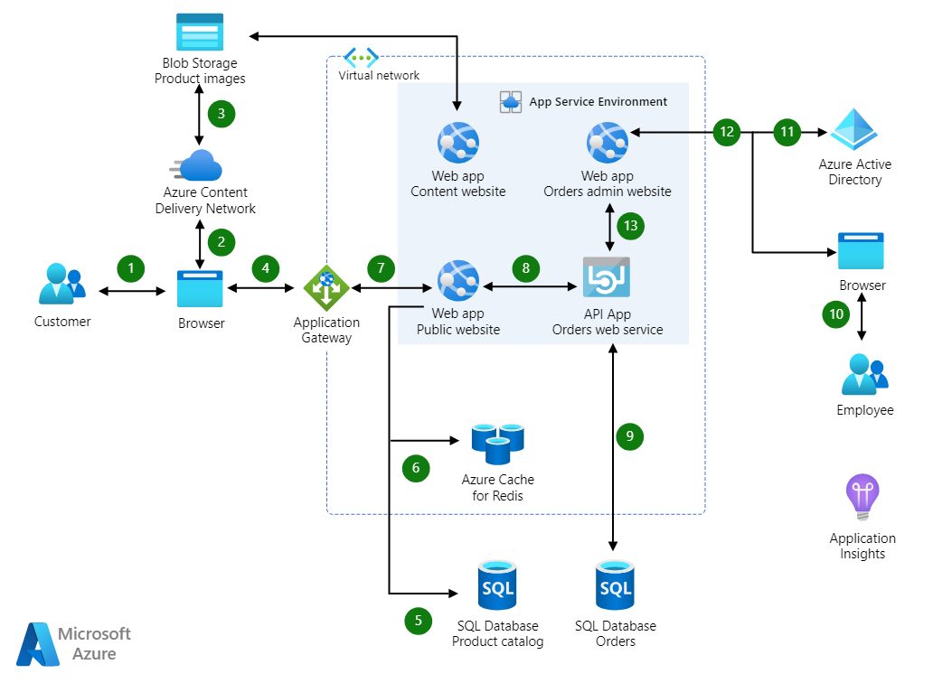

## Dataflow

1. Customer accesses the public website in the browser.
2. Browser pulls static resources and product images from Azure Content Delivery Network.
3. Content Delivery Network pulls product images from blob storage.
4. Customer searches for products.
5. Public website pulls product catalogue from product database.
6. Page output is cached in the Azure Cache for Redis.
7. Customers create new orders.
8. Public website invokes orders web service.
9. Orders web service saves/loads orders from Azure SQL Database.
10. Employee accesses the admin website in the browser.
11. Employee authenticates against Azure Active Directory (Azure AD).
12. Employee searches orders.
13. Admin website invokes orders web service.

**Reference List**

1. <https://learn.microsoft.com/en-us/azure/architecture/web-apps/idea/scalable-ecommerce-web-app>
2. <https://learn.microsoft.com/en-us/azure/architecture/web-apps/idea/ecommerce-website-running-in-secured-ase>
3. https://www.avigilon.com/blog/cloud-vs-on-premise-security
4. https://learn.microsoft.com/en-us/azure/cloud-adoption-framework/govern/policy-compliance/business-risk
5. https://www.vmware.com/topics/glossary/content/cloud-roi.html
6. https://companycom/blog/in-house-vs-outsourced-data-centers/
7. https://abouttmc.com/microsoft-azure-cloud/microsoft-azure-cloud-cost-of-ownership/